Exam 1
Tahmina
library(tidyverse)
── Attaching core tidyverse packages ──────────────────────── tidyverse 2.0.0 ──
✔ dplyr 1.1.4 ✔ readr 2.1.5
✔ forcats 1.0.0 ✔ stringr 1.5.1
✔ ggplot2 3.5.2 ✔ tibble 3.3.0
✔ lubridate 1.9.4 ✔ tidyr 1.3.1
✔ purrr 1.1.0
── Conflicts ────────────────────────────────────────── tidyverse_conflicts() ──
✖ dplyr::filter() masks stats::filter()
✖ dplyr::lag() masks stats::lag()
ℹ Use the conflicted package (<http://conflicted.r-lib.org/>) to force all conflicts to become errors
1)
df <- data.frame(hours=c(1, 2, 4, 5, 5, 6, 6, 7, 8, 10, 11, 11, 12, 12, 14),
score=c(64, 66, 76, 73, 74, 81, 83, 82, 80, 88, 84, 82, 91, 93, 89))
df
hours score
1 1 64
2 2 66
3 4 76
4 5 73
5 5 74
6 6 81
7 6 83
8 7 82
9 8 80
10 10 88
11 11 84
12 11 82
13 12 91
14 12 93
15 14 89
2)
mean(df$score); median(df$score); max(df$score); min(df$score)
[1] 80.4
[1] 82
[1] 93
[1] 64
3)
boxplot(df$score, main="Boxplot: score", ylab="score")
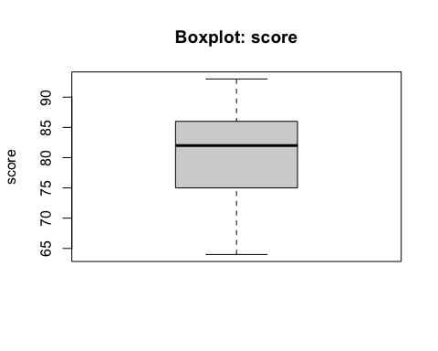
Ans:No outliers are indicated here.
4)
hist(df$score, main="Histogram: score", xlab="score")
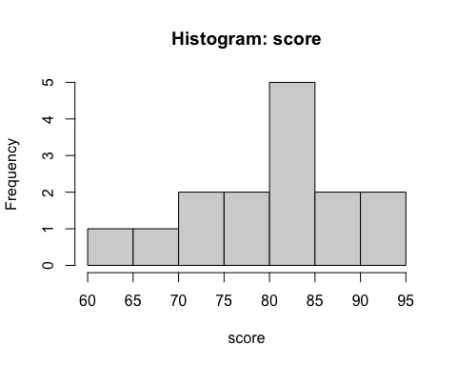
Ans: Roughly unimodal, slightly left-skew (mild negative skew). Close enough to normal for our purposes.
5)
modelEXAM1<- lm(score~hours,data=df)
summary(modelEXAM1)
Call:
lm(formula = score ~ hours, data = df)
Residuals:
Min 1Q Median 3Q Max
-5.140 -3.219 -1.193 2.816 5.772
Coefficients:
Estimate Std. Error t value Pr(>|t|)
(Intercept) 65.334 2.106 31.023 1.41e-13 ***
hours 1.982 0.248 7.995 2.25e-06 ***
---
Signif. codes: 0 '***' 0.001 '**' 0.01 '*' 0.05 '.' 0.1 ' ' 1
Residual standard error: 3.641 on 13 degrees of freedom
Multiple R-squared: 0.831, Adjusted R-squared: 0.818
F-statistic: 63.91 on 1 and 13 DF, p-value: 2.253e-06
6)
coef(modelEXAM1)["hours"]
hours
1.982375
Interpretation: Slope ≈ 1.982. tht means for each additional study hour, the expected exam score increases by ~1.98 points (on average).
7)
plot(score ~ hours, data=df, pch=19)
abline(modelEXAM1, lwd=2)
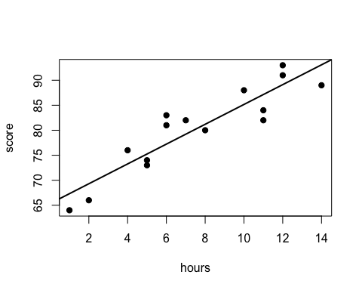
Ans: Clear positive linear trend → scatter plot indicate that a linear relationship exists between hours and score.
8)
cor(df$hours, df$score)
[1] 0.9115809
9)
confint(modelEXAM1, level=0.90)["hours", ]
5 % 95 %
1.543247 2.421502
observe_value<-df$score[df$hours==8]
observe_value
[1] 80
11)
expected_value<-predict(modelEXAM1,newdata = data.frame(hours=8))
expected_value
1
81.19295
12)
residual_8<-80 - predict(modelEXAM1, data.frame(hours=8))
residual_8
1
-1.19295
Ans: Residual is −1.193 → observed is below the regression line (slightly below expected).
13)
range(df$hours)
[1] 1 14
Ans:Yes. model should be used to find an expected value of 13 hours because 13 is inside the observed range [1, 14], so this is interpolation (appropriate).
expected_value_13<-predict(modelEXAM1,newdata = data.frame(hours=13))
expected_value_13
1
91.10482
15)
all_residual<-resid(modelEXAM1)
all_residual
1 2 3 4 5 6 7 8
-3.316327 -3.298701 2.736549 -2.245826 -1.245826 3.771800 5.771800 2.789425
9 10 11 12 13 14 15
-1.192950 2.842301 -3.140074 -5.140074 1.877551 3.877551 -4.087199
16)
all_fitted<-fitted(modelEXAM1)
all_fitted
1 2 3 4 5 6 7 8
67.31633 69.29870 73.26345 75.24583 75.24583 77.22820 77.22820 79.21058
9 10 11 12 13 14 15
81.19295 85.15770 87.14007 87.14007 89.12245 89.12245 93.08720
17)
plot(all_residual, pch = 19,
xlab = "Observation index", ylab = "Residual",
main = " All_residuals")
abline(h = 0, lty = 2)
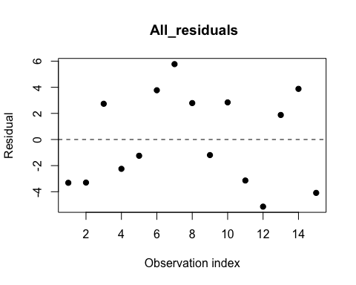
18)
Ans: Residuals look fairly random around 0 with roughly constant spread which supports linear model assumptions.
qqnorm(all_residual)
qqline(all_residual)
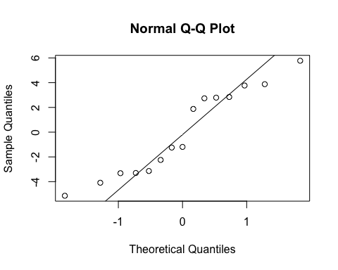
Ans: Points are close to the line that means residuals are approximately normal (small deviations at the tails are fine).
20(a)
anova(modelEXAM1)
Analysis of Variance Table
Response: score
Df Sum Sq Mean Sq F value Pr(>F)
hours 1 847.27 847.27 63.914 2.253e-06 ***
Residuals 13 172.33 13.26
---
Signif. codes: 0 '***' 0.001 '**' 0.01 '*' 0.05 '.' 0.1 ' ' 1
Ans: F_value=63.914
20(b)
F_cri<-qf(0.95, df1=1, df2=13)
F_cri
[1] 4.667193
20(c)
null hypothesis H0: slope = 0 (which means no linear relationship exist here).
20(d)
Ans: since F_value=63.914> 4.667193 and p_value<0.05 it rejects H0. There is a significant linear relationship between hours and score.
####Exam 1 part2####
1(a)
A <-matrix(c(10,8,
5,12),ncol = 2, byrow = TRUE)
A
[,1] [,2]
[1,] 10 8
[2,] 5 12
1(b)
B <-matrix(c(5,3,
15,6
),ncol = 2, byrow = TRUE)
B
[,1] [,2]
[1,] 5 3
[2,] 15 6
1(c)
C <-matrix(c(1,-4,5,
6,0,-3,
2,1,3),ncol = 3, byrow = TRUE)
C
[,1] [,2] [,3]
[1,] 1 -4 5
[2,] 6 0 -3
[3,] 2 1 3
1(d)
D <-matrix(c(-3,7,2,
3,-2,-10),ncol = 3, byrow = TRUE)
D
[,1] [,2] [,3]
[1,] -3 7 2
[2,] 3 -2 -10
1(e)
E <-matrix(c(1,-4,5,-10,
6,0,-3 ,6,
12,5,-11,-4),ncol = 4, byrow = TRUE)
E
[,1] [,2] [,3] [,4]
[1,] 1 -4 5 -10
[2,] 6 0 -3 6
[3,] 12 5 -11 -4
1(f)
F<-matrix(c(-3 , 7 , 2 , 7 ,
3 , -2 , -10 , -2 ,
1 , 0 , 5 , -10),ncol = 4, byrow = TRUE)
F
[,1] [,2] [,3] [,4]
[1,] -3 7 2 7
[2,] 3 -2 -10 -2
[3,] 1 0 5 -10
2)
AB<- A%*%B
AB
[,1] [,2]
[1,] 170 78
[2,] 205 87
3)
t(F)
[,1] [,2] [,3]
[1,] -3 3 1
[2,] 7 -2 0
[3,] 2 -10 5
[4,] 7 -2 -10
4)
det(C)
[1] 129
#as nonzero it invertable
solve(C)
[,1] [,2] [,3]
[1,] 0.02325581 0.13178295 0.09302326
[2,] -0.18604651 -0.05426357 0.25581395
[3,] 0.04651163 -0.06976744 0.18604651
5)
5*t(D)
[,1] [,2]
[1,] -15 15
[2,] 35 -10
[3,] 10 -50
6)
Xm <- cbind(1, df$hours)
ym <- df$score
interceptandslope <- solve(t(Xm) %*% Xm) %*% t(Xm) %*% ym
interceptandslope
[,1]
[1,] 65.333952
[2,] 1.982375
Ans: Intercept = 65.334, Slope = 1.982 both are same .
7)
rank<-qr(F)$rank
rank
[1] 3

